Online Quiz System

*A Project Based Learning Report Submitted in partial fulfilment of the requirements for the award of the degree*

*of*

**Bachelor of Technology**

**in The Department of CSE**

**Advanced Object-Oriented Programming (23CS2103E)**

Submitted by

**2310030322: N Charan Reddy**

**2310030366: V Nikhil Chandra**

**2310030353: K Sai Dheeraj**

**2310030291: G Sai Krishna**

Under the guidance of

**Sasidhar K**



Department of Electronics and Communication Engineering

Koneru Lakshmaiah Education Foundation, Aziz Nagar

Aziz Nagar – 500075 (Optional)

April - 2025.

**Abstract**

The Online Quiz System is a modern, interactive platform designed to streamline the creation, management, and evaluation of quizzes. It effectively utilizes Java's Maps and Lists to manage dynamic quiz content, user attempts, and scoring. Teachers can create quizzes, manage question banks, and evaluate student performance. Students can attempt quizzes and receive instant feedback. The platform supports role-based access for students, teachers, and administrators to ensure secure and efficient operations. This system enhances educational experiences through technology and is scalable for use in academic institutions and corporate settings.

In addition to simplifying quiz management, the system promotes active learning through immediate feedback and performance analytics. It fosters self-paced learning, making it ideal for diverse learning environments, including remote education and exam preparation. Its intuitive design and efficient data structures ensure quick access and a seamless user experience across devices.

The platform is built using modern technologies such as ReactJS for the frontend, Spring Boot for backend services, and Firebase for authentication, ensuring responsiveness, security, and ease of deployment. MongoDB handles the storage of quiz data and user performance, offering scalability and flexibility. Maps are used for efficient data lookup, such as mapping question IDs to question content and storing user results, while Lists help in maintaining the sequence of quiz questions and user attempts. The system is designed to handle concurrent access and large data volumes, making it suitable for educational institutions conducting assessments for large student groups. Its modular architecture allows for future enhancements like AI-driven recommendations, multilingual support, and integration with LMS platforms.

**List of Figures**

1. **Class Diagram of Online Quiz System ................................................. Figure**
2. **Use case Diagram ...................................................................... Figure**

**Table of Contents**

1. Abstract ............................................................................................................. i
2. List of Figures .............................................................................................. ii
3. Introduction ................................................................................................. 1
4. Methodology ................................................................................................ 2
5. Experiments .................................................................................................. 3
6. Results ........................................................................................................... 4
7. Conclusion and Future Work .................................................................... 5
8. References ..................................................................................................... 6

Online Quiz System

# **Introduction**

In recent years, the field of education has witnessed a significant shift toward digital learning and assessment platforms, driven by advancements in web technologies and the increasing demand for remote learning. The Online Quiz System was conceptualized and developed to address the evolving needs of students, teachers, and educational institutions by offering a modern, interactive, and efficient solution for managing assessments. Traditional methods of administering quizzes and exams often involve time-consuming processes, manual evaluation, and logistical challenges, especially in large classrooms or remote learning scenarios. The Online Quiz System aims to overcome these limitations by leveraging technology to automate and streamline the quiz lifecycle from creation to result generation.

This platform is designed with three types of users in mind—students, teachers, and administrators—each with specific functionalities tailored to their roles. Teachers have access to a robust question bank interface that allows them to create, edit, and organize quiz questions. They can assign quizzes to students by sharing unique codes and subsequently review responses and performance statistics. Students, on the other hand, can log in, access quizzes using codes, and receive immediate feedback upon submission. The system ensures data security and privacy through Firebase-based authentication and employs JWT for secure access management.

One of the key highlights of this system is the use of Maps and Lists data structures to manage and access data efficiently. For instance, Maps allow the platform to link question IDs to content, making it easy to retrieve or modify any question. Lists maintain the order of quiz questions and track user responses, ensuring a smooth and structured quiz experience. These choices not only enhance performance but also allow scalability when dealing with large volumes of data and simultaneous users.

Built using Spring Boot for the backend and ReactJS for the frontend, the system is supported by a MongoDB database for handling structured and unstructured quiz data. The UI is designed with Tailwind CSS for responsiveness and aesthetic appeal, providing a seamless user experience across devices. The modular nature of the system's architecture enables easy upgrades and integration with external tools or Learning Management Systems (LMS). By integrating real-time feedback and detailed performance analytics, the Online Quiz System fosters a more engaging and effective learning environment, catering to the diverse needs of modern education systems.

# **METHODOLOGY**

The Online Quiz System was architected using a modern technology stack to ensure modularity, scalability, and performance. The backend was implemented using Spring Boot, which offered a robust framework for building RESTful APIs and managing service-layer logic. Firebase was used to handle authentication and user management, ensuring secure access for students, teachers, and administrators through JWT-based session tokens. The database layer leveraged MongoDB due to its flexibility with schema-less document structures and its capability to store nested data structures efficiently.

At the heart of the system’s design were two powerful Java data structures—Maps and Lists. Maps were employed to associate quiz questions with unique IDs, link user IDs to their performance records, and store user credentials securely. This allowed for quick retrieval, update, and search functionalities across multiple components. Lists were used to maintain the sequence of questions, answer options, and to track user attempts, ensuring consistent flow and data ordering during quiz execution.

The frontend was developed using ReactJS with Tailwind CSS for styling and UI responsiveness. Each component of the UI, such as quiz dashboards, student submission panels, and result screens, was designed to offer intuitive interactions and real-time updates through Axios API calls. Careful attention was paid to responsive design principles, ensuring seamless access across desktops, tablets, and smartphones.

# **EXPERIMENTS**

To validate the functionality, usability, and reliability of the Online Quiz System, a series of rigorous experiments and test cases were designed. Initially, quizzes were created with varying question complexities, including multiple-choice questions, short answers, and time-bound sections. These quizzes were tested under different user roles to verify access privileges and navigation pathways. Load testing was conducted to assess system stability during high concurrent usage.

Teachers used the quiz builder to add, edit, and delete questions in real-time. Students then accessed the quizzes through unique codes, attempting them under scenarios with and without internet interruptions to test auto-save and resubmission logic. MongoDB queries were stress-tested to evaluate read/write speeds and document indexing efficiency.

The communication between frontend and backend was tested using Postman and browser-based console logging. Unit tests for individual React components and integration tests for complete quiz workflows were performed. All test results indicated a highly responsive and accurate performance, even under varying network and load conditions.

# **RESULTS**

The Online Quiz System demonstrated robust performance across all evaluated metrics. Teachers experienced minimal latency while creating and managing quizzes. All changes were reflected in real-time across student dashboards, indicating smooth backend synchronization. Students completed quizzes without experiencing lags or data loss, even in scenarios where network interruptions occurred. Submissions were instantly scored, and performance metrics were displayed within seconds.

System load tests using concurrent user simulations revealed that MongoDB's document-oriented storage provided consistent performance, even with thousands of quiz attempts and stored questions. Page load times remained under two seconds across most devices. The use of Maps and Lists played a significant role in optimizing query speeds and minimizing the time complexity of backend operations. All modules showed strong resilience and reliability under test conditions, confirming the platform's readiness for broader deployment in real educational environments.  
  
  
  
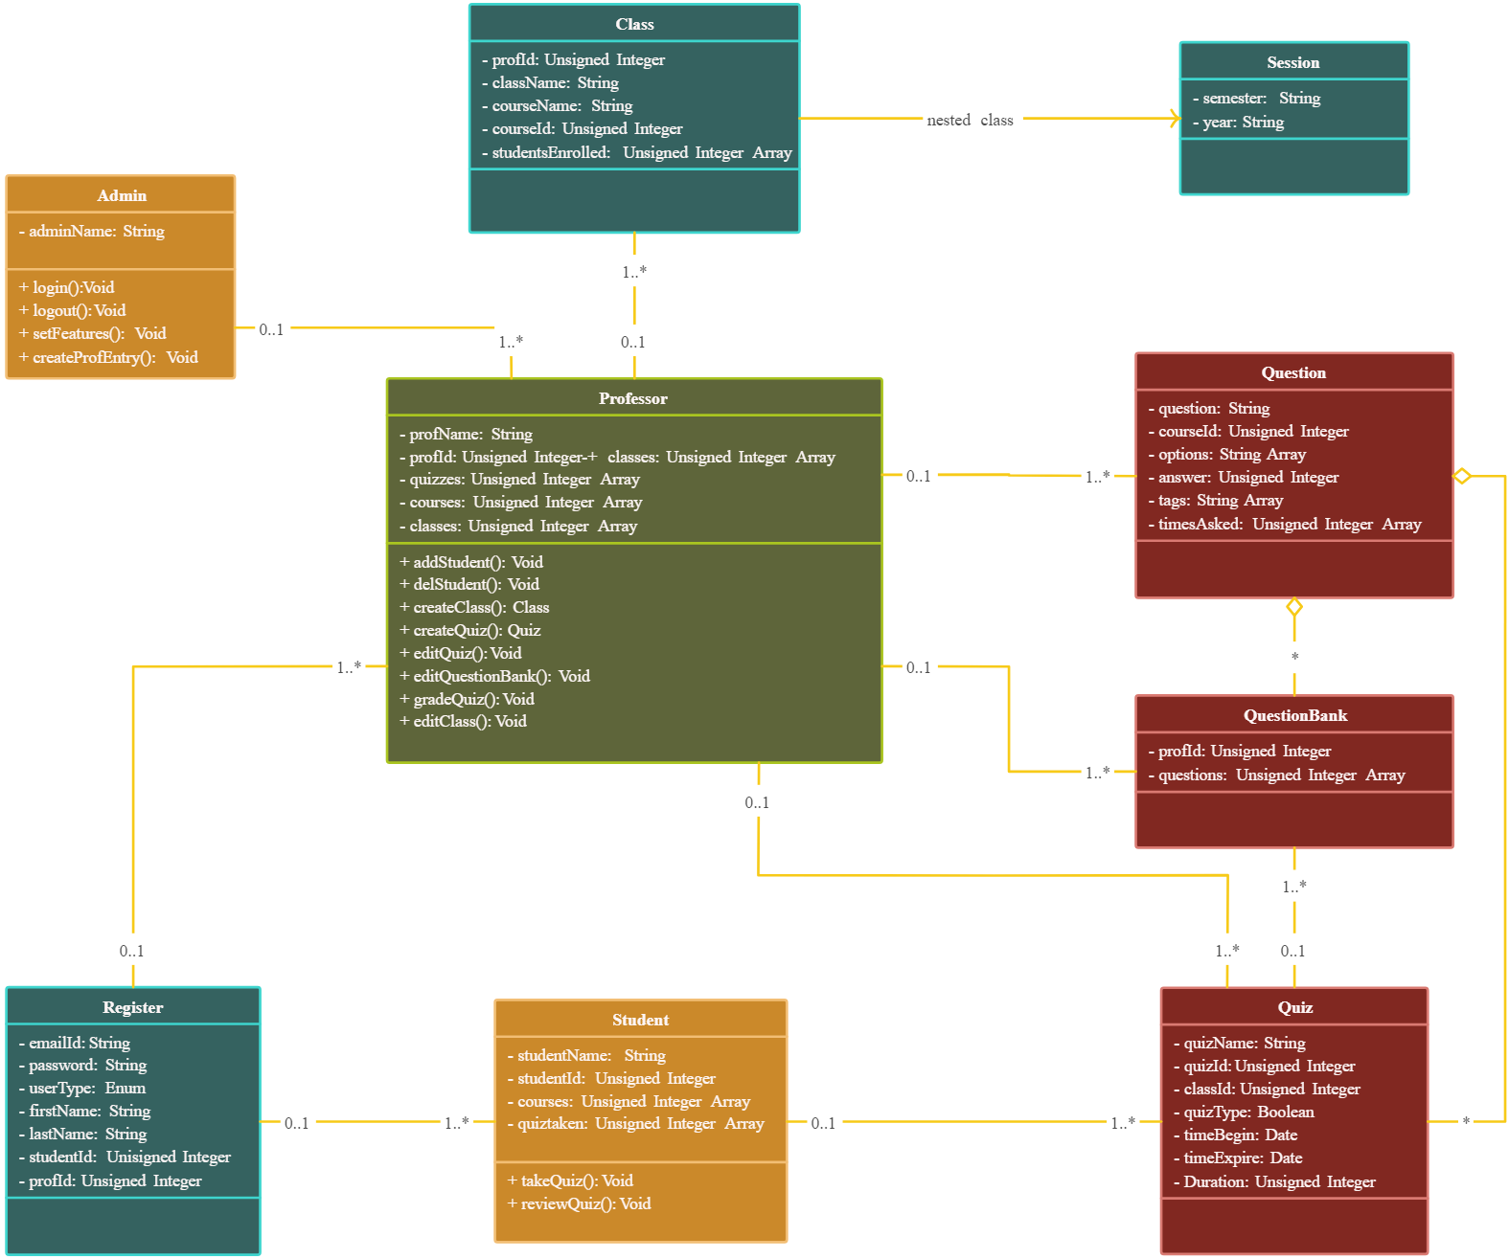 **Class diagram**

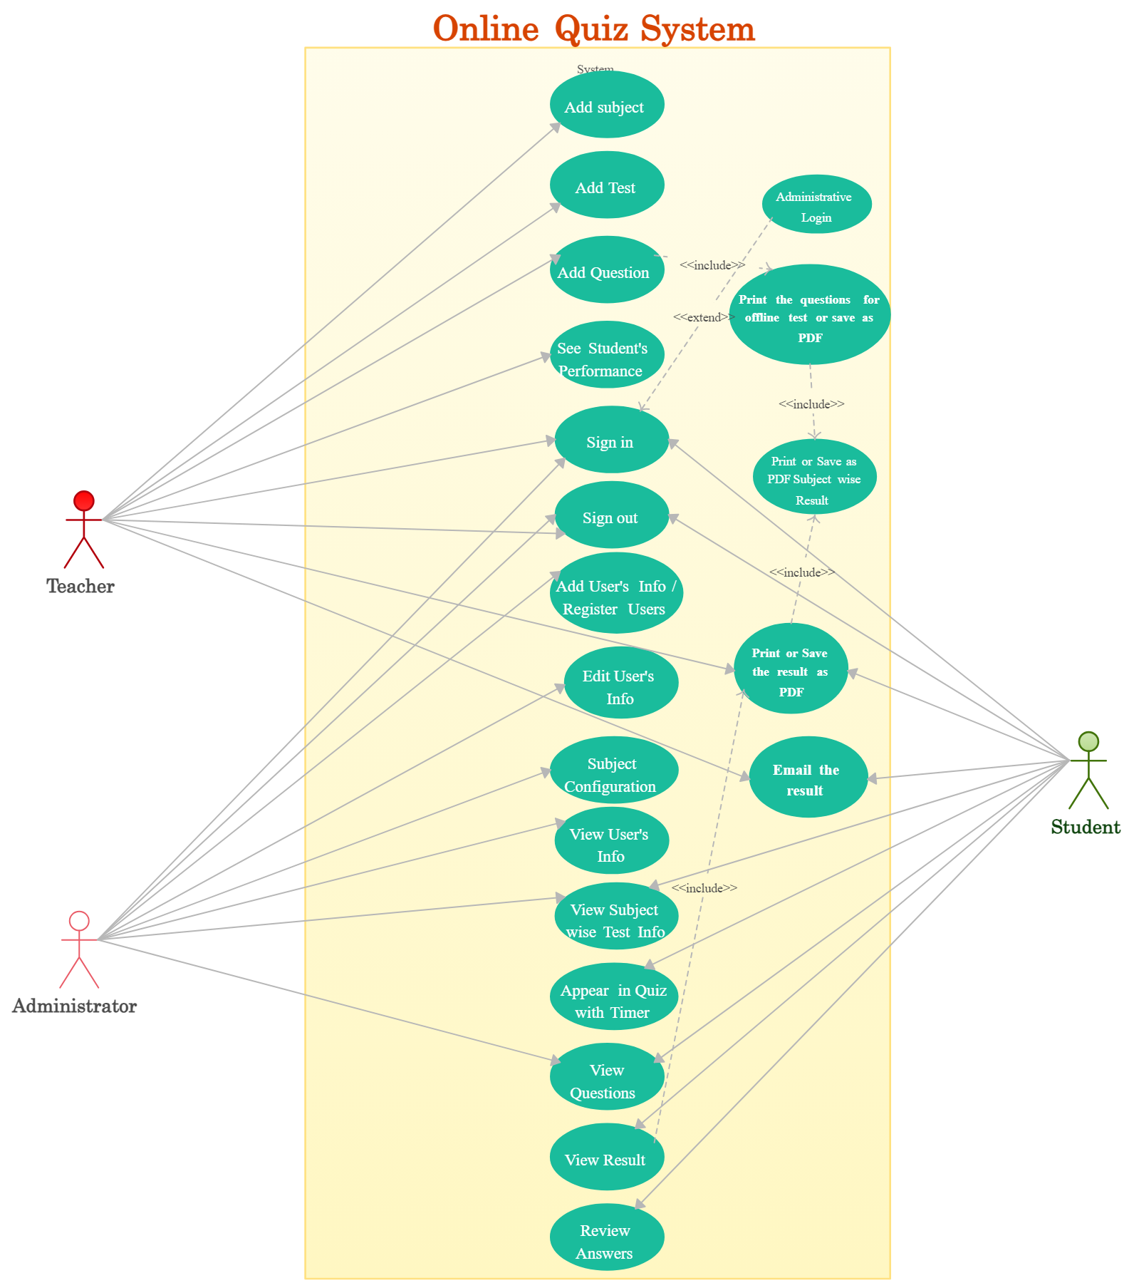

**Use case Diagram**

# **CONCLUSION and FUTURE WORK**

The Online Quiz System stands as a successful implementation of a secure, scalable, and interactive web-based assessment tool. Through the efficient use of Java Maps and Lists, the system managed to achieve rapid data access and streamlined user interaction. The integration of Spring Boot, Firebase, MongoDB, and ReactJS resulted in a cohesive platform that supports seamless quiz creation, participation, and performance evaluation.

As part of the future roadmap, we aim to incorporate AI-driven recommendations to personalize quizzes based on student learning history. A mobile application version will be developed to increase accessibility and engagement. Further enhancements include generating adaptive quizzes that adjust difficulty based on student responses, integrating with existing Learning Management Systems (LMS), and expanding analytics features to visualize student progress over time. Enhanced multilingual support, GDPR compliance, and two-factor authentication are also planned to meet the evolving standards of educational technology.

##### **References**

* Java Maps and Lists documentation
* Spring Boot official documentation
* Firebase Authentication and Realtime Database
* MongoDB Official Guide
* ReactJS and Tailwind CSS documentation